**REGISTRATION FORM**

<!DOCTYPE html>

<html lang="en">

<head>

    <meta charset="UTF-8">

    <meta name="viewport" content="width=device-width, initial-scale=1.0">

    <title>Form validation</title>

    <script type ="text/javascript" >

    function validation()

    {

        var name=document.getElementById("name");

        var email=document.getElementById("email");

        var phoneno=document.getElementById("phoneno");

        if(name.value.trim()== "")

        {

            alert("Please fill the name");

            return false;

        }

        else if(email.value.trim()=="")

        {

            alert("Please fill the Email Id");

            return false;

        }

        else if (date=="")

        {

            alert("Fill the Date");

            return false;

        }

        else if (phoneno.value.trim() == "")

        {

            alert ("Fill the Phone no");

            return false;

        }

        else if(password.value.trim()=="")

        {

            alert("Please fill the Password");

            return false;

        }

        else if(password.value.trim().length<5)

        {

            alert("Password is too short");

            return false;

        }

        else{

            true;

        }

    }

    </script>

    <style>

        h1{

            color:black;

            text-decoration:underline ;

            font-family: 'Segoe UI', Tahoma, Geneva, Verdana, sans-serif;

        }

        div{

        font-family: Verdana, Geneva, Tahoma, sans-serif;

        border: solid crimson 10px;

        padding: 20px;

        background-color:rgb(35, 211, 211);

        display: flex;

        border-radius: 2px;

         width: 400px;

        }

    </style>

</head>

<body>

    <div>

    <form id ="form1" action="welcome.html" onsubmit="return validation()" autocomplete="off" >

        <h1>Form Registration</h1>

        <label>Name</label>

        <input id ="name" placeholder="Enter the Name  " type="text" >

        <br><br>

        <label>Email</label>

        <input id="email" placeholder = "Enter Email Id" type="text">

        <br><br>

        <label >Dob</label>

        <input type="date" id="date" >

        <br><br>

        <label >Phone No</label>

        <input type="number" name="phoneno" id="phoneno" placeholder="Enter the Phone No">

        <br><br>

        <label >Password</label>

        <input type="password" id="password" placeholder="Enter the Password">

        <br><br>

        <input  type="submit"></input>

    </form>

</div>

</body>

</html>

**OUTPUT:**

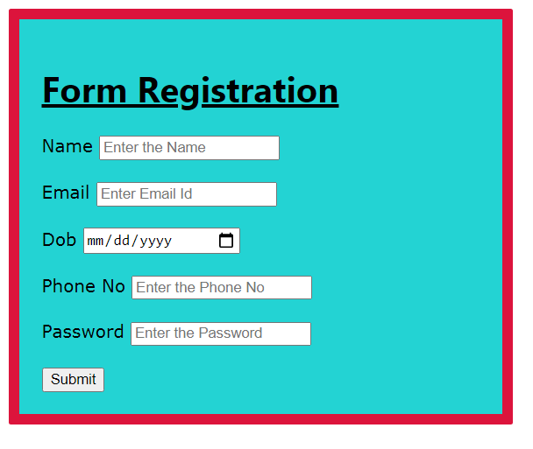

**Form validation-1**

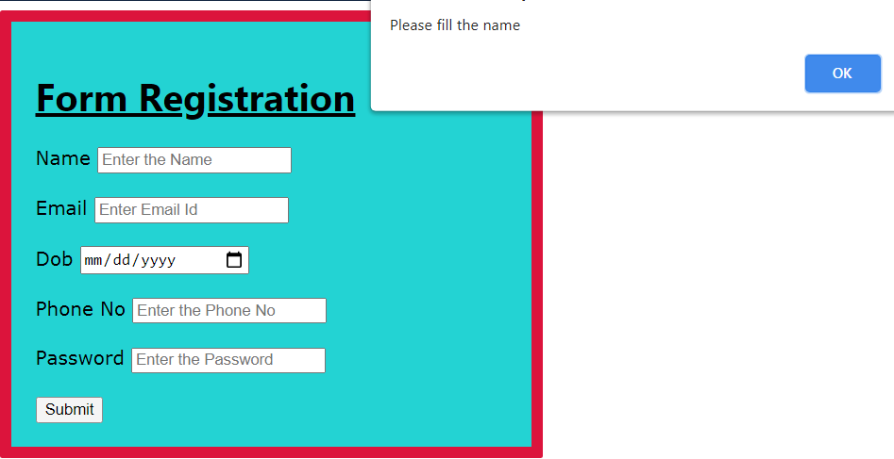

**Form validation – 2**

